How an AI Agent Actually Works — A
Practical Guide for Treasury & Finance
By Felix Grevy, SVP Platform, Data & AI

Inside TAI, Kyriba’s embedded agent: LLMs, tools, MCP, governance & evaluation

Executive summary
- What the Agent does:Kyriba’s Agent can securely call tools to retrieve data, trigger workflows, and analyze results — always within the permissions and controls you already define in Kyriba.

- Business value:Faster cash visibility, assisted analysis, and decision support with traceable sources and full auditability.

- Why it matters:Finance leaders gain speed and confidence to act, without ever compromising on trust, compliance, or control.
Why agents now, and why in Treasury?
Treasury decisions are time‑bound, data‑heavy, and policy‑constrained. Agents excel where you need to:
- Aggregate multi‑system data (bank balances, cash forecasts, payables) instantly.

- Run repeatable analyses (FX exposure, variance explanations, liquidity headroom) on demand.

- Propose next actions (e.g., move excess cash, accelerate collections) with the right approvals and guardrails.

Embedding the agent inside Kyriba means it sees exactly what you’re allowed to see, uses your existing roles & permissions, and leaves an audit trail like any other Kyriba workflow.

Bottom line: An agent is a policy‑aware teammate. It talks, acts, and proves what it did.

How does an agent work ?
An agent interprets the user’s request and then engages in a chain of thought—a reasoning process where it breaks down the problem into steps. Based on this reasoning, the agent identifies which tools or data sources might help, calls them, observes the results, and adapts its plan if needed. This loop continues until the agent can provide a complete, reliable answer to the user.

Large Language Model (LLM)
The key component of an agent is the Large Language Model (LLM)—the “brain” that performs reasoning and planning.
LLMs were popularized by OpenAI with the release of ChatGPT in November 2022, but the underlying breakthrough came earlier, with Google researchers’ 2017 paper “Attention Is All You Need.” This work introduced the transformer architecture, which made it possible to train models much more effectively.
The idea is revolutionary: instead of hard-coding rules, the model is trained on vast amounts of text—such as content from millions of web pages and books—so that it learns statistical patterns of language and can generate coherent, well-formed sentences. Modern LLMs achieve this scale through billions of parameters—the adjustable weights inside the neural network. Smaller models may have around 7–8 billion parameters, while the largest frontier models can exceed 100 billion parameters. More parameters generally allow the model to capture more complex patterns, though they also require vastly greater computing power.
To improve usefulness and safety, an additional process called Reinforcement Learning with Human Feedback (RLHF) is applied. In this step, humans review outputs and guide the model on how to answer questions in ways that are more accurate, relevant, and aligned with user expectations.
The initial training of an LLM — compressing vast amounts of knowledge into billions of parameters — requires enormous computational power, typically using large clusters of GPUs or specialized AI accelerators. On top of this, the Reinforcement Learning with Human Feedback (RLHF) process adds weeks or months of fine-tuning, as humans guide the model to produce more useful and aligned answers.
Overall, it can take several months to produce a single model, which explains why new generations (e.g., from GPT-3.5 to GPT-4) are released on a multi-month cycle rather than continuously.

Tokens
LLMs process language using tokens—small units of text that can be as short as a single character or as long as a word, but on average about four characters in English. Instead of reading sentences directly, the model breaks everything down into these tokens.
The model’s core task is to predict the next token in a sequence, based on all the tokens it has already seen. It does this using the transformer architecture: layers of attention mechanisms and neural networks that apply advanced mathematics and statistical patterns learned during training.
This process, called inference, is what happens each time you interact with the model. Unlike the months-long training process, inference is much faster and requires far less computation, which makes real-time use possible.

Prompt
Every interaction with an LLM begins with a prompt — the input text that frames the task. A prompt can be as simple as a direct question (“Explain photosynthesis”), which the model can answer from its trained knowledge.
However, there is a limit to how much text an LLM can consider at once. This is called the context window, and it is measured in tokens. Depending on the model, context windows today range from around 32,000 tokens (roughly 20–25 pages of text) to more than 200,000 tokens (an entire book). This blog has roughly 2800 tokens . Prompts must not exceed the context window size.
In the initial version of ChatGPT, the main innovation was a chat interface that allowed users to have natural conversations with the LLM. The model responded using patterns and knowledge it had learned during training, but that knowledge was static—limited to the information available up to its training cut-off date.
This meant that ChatGPT could answer general questions, explain concepts, or generate text in many styles, but it could not access the latest news, facts, or real-time data, since it wasn’t connected to the internet or external systems.

Tools
The next breakthrough came with the introduction of tools. Instead of relying only on its static training, the LLM could now decide to call an external tool—for example, a search engine.
Based on the user’s request, the model could trigger a search query, process the results, combine them with the ongoing conversation, and then produce a final answer.
For instance, if you ask “What’s the weather tomorrow?” the LLM must call a tool to fetch real-time weather data, since that information isn’t part of its training. Once the result is returned, the LLM integrates it into the conversation and provides the final answer.
This capability removed one of the biggest limitations of early LLMs: it allowed them to access up-to-date information and respond accurately to questions about events or facts that happened after the training cut-off date.
Tools are the way for an LLM to observe a system and perform actions.
They extend the model beyond language prediction: instead of only generating text, the LLM can decide to call a tool to look up data, run a calculation, query a database, or trigger an external process.

Reasoning Loop

A typical agent works through a reasoning loop: Plan → Act (call tools) → Observe → Refine → Answer. The agent repeats this loop until it has gathered enough information to respond—or, in some cases, to request approval before taking an action.
The effectiveness of this loop also depends on the context window of the LLM, which defines how much of the conversation and tool outputs it can keep in memory at once. A larger context window allows the agent to consider longer conversations, detailed reports, or multiple tool calls in sequence, making its reasoning more accurate and reliable.
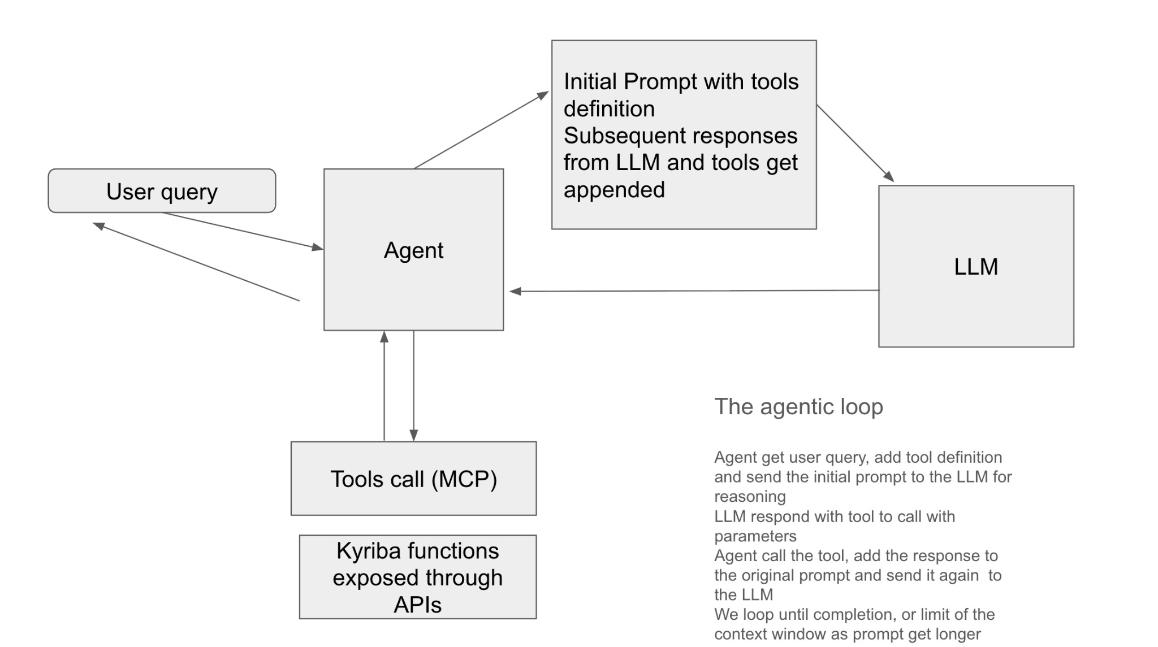

How Kyriba wires this together (architecture at a glance)
To deliver the best agentic experience for finance professionals—where safety and trust are paramount—Kyriba has built its Agent following industry best practices and the most advanced AI concepts.
- Agentic Orchestration
The reasoning loop (Plan → Act → Observe → Refine → Answer) is orchestrated using LangChain and LangGraph, frameworks purpose-built for robust, explainable, and auditable agent workflows, refined by Kyriba for enterprise-grade scalability and constraints.
- Large Language Model (LLM)
For complex queries, Kyriba leverages a frontier LLM with over 100 billion parameters, delivering both accuracy and depth of reasoning. Kyriba also applies an evaluation framework that tests LLM and MCP tool performance across a large set of treasury-related questions, using LLM-as-a-Judge techniques to benchmark and select the most suitable model.
- Safety & Compliance
The LLM is privately hosted within Kyriba’s secured environment (Databricks and AWS). All usage is governed by contractual Data Processing Agreements, ensuring that customer data is never used for training and cannot leak outside Kyriba’s environment. Strict controls on data residency, access rights, and auditability ensure the Agent always operates within the highest standards of compliance and trust.
- Tool Calling via MCP
Tool usage is managed through the Model Context Protocol (MCP), an emerging industry standard initiated by Anthropic. Much like USB-C for AI, MCP provides a universal way for LLMs to call APIs. In Kyriba’s setup, MCP executes API calls on behalf of the user, always respecting data permissions, scopes, and segregation of duties.
All interactions between Kyriba, the Agent, and MCP flow through an API Gateway, which provides:
- Centralized security → Authentication, encryption, and access control for every call.
- Data integrity → Ensures payloads cannot be altered in transit.
- Traffic management → Scales safely while preventing misuse or overload.
- Monitoring & auditability → Every call is logged and traceable for compliance.

Our early investment in API-first strategy, shaped Kyriba around secure, scalable, exposing well-governed APIs—laying the foundation for our agent capabilities.

Walkthrough Example

“Where can we safely free up $10M by Friday?”
- Understand the ask:The agent parses the request and extracts constraints (amount, deadline, currencies, entities) and applicable policies (investment guidelines, cut-off times).

- Plan:Decide what to fetch: list of entities, current bank balances, forecasted inflows/outflows, committed payments, available credit.

- Identify required tools:Select the relevant MCP tools.

- Call tools:

○ For each entity: getBankBalances(entity=X, asOf=today)
○ For each entity: getForecast(entity=X, horizon=7d)
○ getReport(PendingPayment) ○ getReport(CreditLine)

- Analyze:Compute liquidity headroom by bank/account, consider FX effects, and ensure minimum balances and policy limits are respected.

- Propose options:e.g. “Move $6.2M from Entity A to Entity B today; convert €3.8M to USD tomorrow; draw $1M on Facility C.”

- Present results:Show numbers, sources, and cut-off risks clearly to the user.

- Act (with approval):The agent can execute recommended actions directly in Kyriba, always subject to segregation of duties and full auditability.

Permissions, Privacy, and Control (Non-Negotiables)
- Role-based access:The agent can only see and do what you are authorized to see and do in Kyriba.

- API scopes & least privilege:Each tool is strictly scoped (e.g., read payments vs.
create payments). Sensitive actions always require explicit approval.

- Data residency & logging:All calls are fully auditable. The agent passes only structured, relevant snippets to the LLM (not full datasets). Reasoning steps are transparently traced and visible to the user in the “Thinking Steps”, including which tools were called.

- Human-in-the-loop:The agent recommends; you decide. Approvals can be enforced at any action level (e.g., payments, transfers, FX), ensuring full control.

Limitations to Keep in Mind
Even with advanced orchestration and controls, it’s important to recognize that LLMs have inherent limitations:
- Context window: An LLM can only “see” a limited amount of text at once. If a request or dataset is too large, the model may struggle to produce coherent results. It is often best to start a new conversation to reset the context window, especially when switching to a different topic.

- Hallucinations:LLMs can sometimes generate plausible-sounding but incorrect information. To mitigate this, Kyriba’s Agent always grounds its answers in tool outputs and reports, with sources visible to the user. Free-form text generation is never used alone to trigger financial actions. However, results should always be double-checked, as hallucination remains an inherent limitation of today’s LLMs.

- Mathematics:LLMs excel at language but are less reliable with precise calculations, since they rely on next-token prediction rather than true arithmetic. To address this, Kyriba’s Agent uses a dedicated calculator tool, ensuring that mathematical operations are accurate and auditable.

Conclusion
Agents represent the next step in applied AI for finance, moving beyond simple chatbots into intelligent assistants that can reason, plan, and act—while staying firmly within the guardrails of trust, compliance, and control.
By combining:
- Frontier LLMs (hundreds of billions of parameters, hosted securely),
- Agentic orchestration frameworks (LangChain and LangGraph),
- Standardized tool connectivity (MCP, respecting roles and permissions), Auditability and human approvals,
Kyriba delivers an enterprise-grade Agent designed for finance professionals who need both speed and safety.
The result: CFOs, treasurers, and finance teams can confidently leverage AI to answer complex liquidity questions, optimize cash management, and take action—always backed by the same trust and rigor that define Kyriba’s platform.
And as the AI industry continues to evolve—with larger context windows, more capable models, and new orchestration methods—Kyriba will continue to adopt the latest advancements to ensure its Agent remains state-of-the-art, empowering finance teams with innovation that is always trustable, responsible, and future-ready.

Learn more about TAI and see how it can bring your treasury to the next level.

Sources

Foundational Research
- Vaswani, A., et al. (2017). Attention Is All You Need. NeurIPS. arXiv:1706.03762

- Brown, T., et al. (2020). Language Models are Few-Shot Learners. NeurIPS (introduces GPT-3). arXiv:2005.14165

- OpenAI (2022). Introducing ChatGPT. Blog post

- Ouyang, L., et al. (2022). Training language models to follow instructions with human feedback. arXiv:2203.02155 (introduces RLHF). arXiv:2203.02155

- OpenAI (2025). Why Language Models Hallucinate. PDF

- Apple Machine Intelligence Research (2024). The Illusion of Thinking in Large Language Models. arXiv:2404.03656

Agentic Frameworks & Tool Use
- LangChain Documentation – https://python.langchain.com

- LangGraph Documentation – https://www.langchain.com/langgraph

- Anthropic (2024). Model Context Protocol (MCP). https://modelcontextprotocol.io
- Kyriba from DX to AX blog

Risks & Limitations
- Ji, Z., et al. (2023). Survey of Hallucination in Natural Language Generation.
arXiv:2302.03626.

- Borji, A. (2023). A Categorical Archive of ChatGPT Failures. arXiv:2302.03494.

- OpenAI (2023). GPT-4 Technical Report. arXiv:2303.08774 (discusses context window, limitations).

Industry / Enterprise AI Context
- McKinsey & Company (2023). The economic potential of generative AI

- Databricks (2024). Building state-of-the-art enterprise agents. Blog post
- Gravitee (2025). Agent 2 Agent and MCP Blog Post

